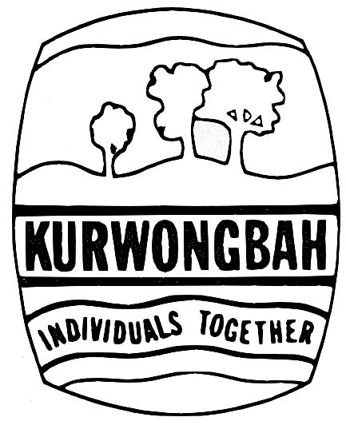
Kurwongbah State School
Eacham Street PETRIE QLD 4502
Telephone: (07) 3481 4333 Fax: (07) 3481 4300

Activity Consent Form – Year 6 Dance Lessons
21 June 2022

Dear Parent/Carer

On Monday 18 July 2022, all Year 6 students we will be commencing dance lessons as part of the Semester 2 Dance Unit ‘Adventures in Dance’.

The aim of the dance lessons is for students to perform, choreograph and respond to dance by exploring ways that dance can be used to express adventure stories drawing on stimulus from movement contexts including martial arts, acrobatics, sport, exercise and other cultural forms.

Each student will be assessed on the dance component of the Arts curriculum.

Activity details:
Classes will commence, during school time, on Monday 18 July 2022 (Term 3 Week 2) and continue on a weekly basis for 8 weeks, excluding the Exhibition week. Each lesson will be held in the Kurwongbah State School hall for 45 minutes per week. The lessons will be conducted by Creative Dance Industries who provide professional dancers/teachers who are well equipped to teach the students skills that will help in many areas of their life. Class teachers will also be supervising lessons and providing more lessons to consolidate learning and complete assessment.

During the 8 lessons students will:
- explore movement and choreographic devices, using the elements of dance to choreograph dances that communicate meaning in adventure stories
- develop technical and expressive skills in fundamental movements including body control, accuracy, alignment, strength, balance and coordination
- perform dance using expressive skills to communicate a choreographer's ideas about an adventure story
- explain how the elements of dance and production elements communicate meaning and use a range of
movement styles/forms by comparing dances from different social, cultural and historical contexts.

Students should wear their school uniform and suitable shoes for dance lessons.

Activity costs: $20.00 in total per child for 8 lessons.
Kurwongbah State School is a cashless school. Preferred payment method is BPOINT (using the BPOINT link on the invoice emailed to you). Payment can also be made by QParents, EFTPOS or Cheque/Money Order (payable to Kurwongbah State School).

Full payment of $20.00 must be made by Thursday 14 July 2022

Refund guidelines for activities:
At Kurwongbah State School we are committed to providing a safe and supportive learning environment for students, staff and volunteers. This commitment includes the health and safety of staff and students when conducting curriculum activities in the school or in other locations.
School excursions and camps enhance a student’s learning by providing opportunities for the student to participate in activities, both curriculum-related and recreational, outside the normal school routine. All planned school excursions are approved by the Principal and endorsed by the Parents and Citizens Association.

State schools are able to charge a fee for:
- An educational service including materials and consumables not defined as instruction, administration and facilities for the education of the student;
- An education service purchased from a provider other than the school where the provider charges the school; and
- A specialised educational program.
A school fee is directed to the purpose for which it is charged.
School fees for excursions and camps are calculated on a cost recovery only basis, according to the number of students who have indicated their attendance.
Participation of students in an excursion or camp is indicated through payment of the excursion or camp fee and provision of a permission form completed by the parent/carer.
As the school budget cannot meet any shortfalls in funding for an excursion or camp due to the subsequent non-participation of a student who had previously indicated attendance of the activity, fees already paid for an excursion or school camp may be refunded in full or in part or not at all, having regard to the associated expenses incurred and the circumstances of the non-participation.
If a parent/carer wishes to apply for a refund due to their child’s non-participation in an excursion or camp activity, they may do so by completing a Request for Refund form available from the school office. Where possible, the request should include the receipt relating to the payment for which a refund is being sought.

If you wish for your child to participate in this activity, please complete the attached consent form and return to your child’s class teacher by Thursday 14 July 2022.

For further information about the activity, please contact your child’s class teacher on 3481 4333.

Yours sincerely

Leanne Odorico Year 6 Teachers
Principal
Kurwongbah State School Kurwongbah State School

Activity Consent Form - Year 6 Dance Lessons

Please return this form to your School Office by Thursday 14 July 2022

Privacy notice
The Department of Education is collecting the personal information requested in this form in order to:
- obtain lawful consent for your child to participate in the activity;
- help coordinate the activity;
- respond to any injury or medical condition that may arise during, or as a result of the activity; and
- update school records where necessary.
The information will only be accessed by authorised school staff and will be dealt with in accordance with the confidentiality requirements of, as applicable, s.426 of the Education (General Provisions) Act 2006 (Qld), the Information Privacy Act 2009 (Qld), and/or the Privacy Act 1988 (Cwlth).
The information will not be disclosed to any other person or agency unless the disclosure is authorised or required by law, or you have given the department permission for the information to be disclosed.

Activity risks and insurance
Please note that the Department of Education does not have personal accident insurance cover for children/students. If your child is injured as a result of an accident or incident while participating in the activity, all costs associated with the injury, including medical costs are the responsibility of the parent/carer. Some incidental medical costs may be covered by Medicare. If you have private health insurance, some costs may also be covered by your provider. Any other costs must be covered by parents/carers. It is up to all parents/carers to decide what types and what level of private insurance they wish to arrange to cover their child. Please take this into consideration in deciding whether or not to allow your child to participate in this activity.
Consent
By signing this form I agree that:
- I have read all of the information contained in this form in relation to the activity (including any attached material) and I am aware that the department does not have personal accident insurance cover for students/children.
- I give consent for my child, _____________________________________________ in ______, to participate in the Dance Lessons commencing on Monday 18 July 2022.
- I will pay to the school the costs detailed in this consent form for my child’s participation in the activity.
- In the event of an accident or illness, school staff may obtain or administer any medical assistance or treatment my child may reasonably require, including contacting my child’s doctor.
- I accept liability for all reasonable costs incurred by the department in obtaining such medical assistance or treatment (including any transportation costs) and undertake to reimburse the department the full amount of those costs.
- I have provided the school all relevant details of my child’s medical or physical needs on registration /enrolment and where relevant have updated this information.

Parent/Carer’s name: _______________________________________________________________(Please print)

Parent/Carer signature: _______________________________________________ Date: ____/____/___

Additional medical information
The school collected medical information about your child at registration/enrolment. This information is stored electronically in OneSchool. If there is any new or updated medical information, please contact the school office for a Change of Details Advice Form prior to the activity.
----------------------------------------------------------------------------------------------------------------------------
Please complete and forward to the School Office.
KURWONGBAH STATE SCHOOL - CREDIT CARD PAYMENT SLIP

Please charge my: ◻ Visa ◻ Master Card

Credit Card Number:

Expiry Date: ____/____ Amount: $20.00

In payment of: Year 6 Dance Lessons Student Name: _________________________

Cardholder’s Name: __________________________ Cardholder’s Signature: ________________

